**MSP**

**VERTICAL HEAVY DUTY SUMP PUMP**

MSP heavy duty sump pumps are vertical, shaft-driven centrifugal slurry pumps designed for transferring abrasive and high-density slurry from sumps, pits and other submersible sources. The heavy duty design of the MSP pumps allows the passage of large particles with a diameter of up to 50mm, Pumps will continue to operate even when the top inlet is not submerged, allowing the liquid level to be lowered to the bottom of the sump or pitSuction extension pipes of up to 2 metres in length can be added to the bottom inlet of the pump to extend the pumping depth. Designed as a fixed installation the MSP provides reliable pumping performance with minimal maintenance requirements and simple servicing.

**Design Features**

Outlet: 40-150mm

Flow rate: 18-1260m3/h

Head: up to 40m

Max. power: up to 110kw

Pump depth: 900-2400mm

Impeller diameter: 188-450mm

Material: 27% were resistant Chrome

Max. Particle size: 12-50mm

**Assembly drawing**

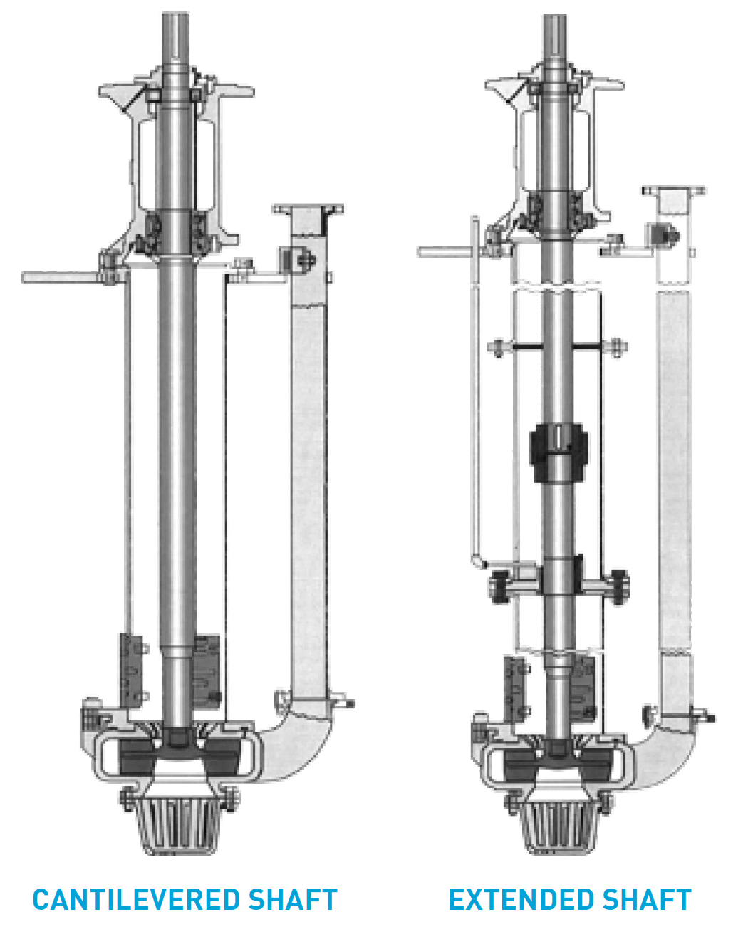

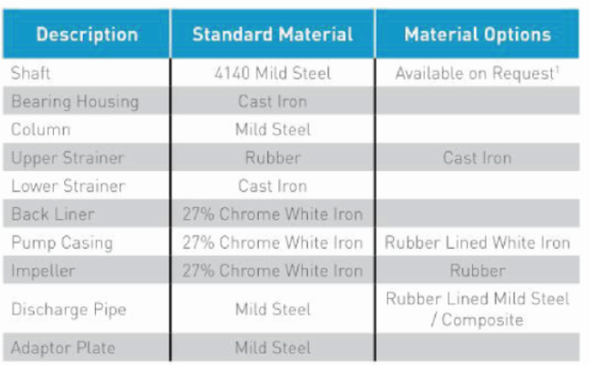

**MST MSP HEAVY DUTY SUMP PUMPS ARE CAPABLE OF PROVIDING RELIABLE AND EFFICIENT PERFORMANCE FOR THE TRANSFER OF ABRAISIVE AND HIGH DENSITY SLURRY FROM SUMPS PITS AND TANKS IN A WIDE RANGE OF MINING, PROCESSING AND HEAVY INDUSTRIAL APPLICATIONS.**

**CANTILEVERED SHAFT**

The standard MSP pumps feature a cantilevered shaft that is up to 2400mm long. The cantilevered shaft means that there is no shaft sealing requirement and the drive end bearings do not come into contact with any pumped product. This reduces the risk of bearing failure and extends the wear life of the pumps

**COLUMN AND DISCHARGE PIPES**

Column and discharge pipes are available in a range of materials to suit the requirements of operators. Standard options include mild steel and rubber-lined mild steel. Composite options are available.

**REMOVABLE STRAINERS**

MSP pumps feature rubber or cast iron upper strainers and cast iron lower strainers to prevent blockages. The strainers are easily removed for servicing or replacement.

**“L” EXTENDED SHAFT**

The extended shaft“L” model features column bearings and shaft seal which further extends the pumping depth and enables the transfer of slurries from deeper sumps and pits.

视频

**MSP VERTICAL SLURRY PUMP PERFORMANCE**

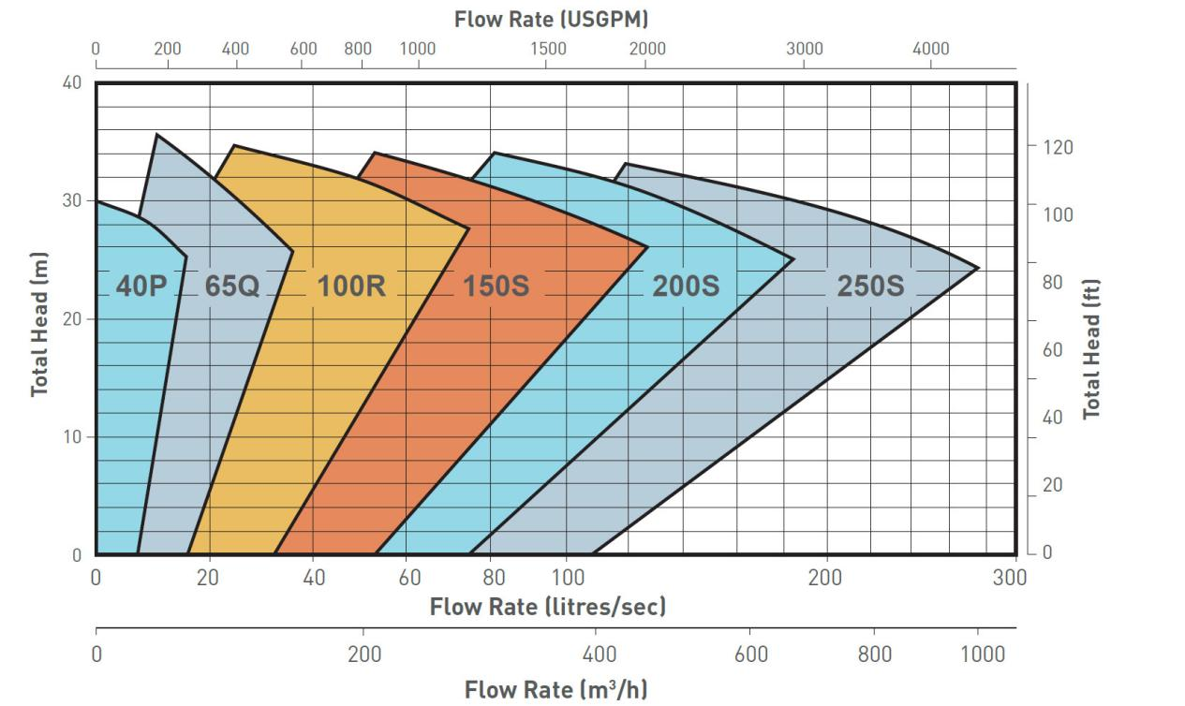

1, What information is needed to offer a slurry pump?

The pump model or the below information.Liquid:

Capacity:_m3/hr

Head:_m

PH:

Specific of gravity:

Voltage:_ V,

Frequency: _hz

2, What material pump can you supply?A05, Natural rubber, ceramics, polyurethane, etc

3, Can you supply special or OEM parts?

Yes, please send me the detailed drawing or parts code to check

4, Do you only supply pumps? Could you supply driven equipment?

Yes, sure, the pumps could be coupled with motor and diesel engine, below brands for your reference Motor: WEG, SIMENS ABB, TECO, and Chinese brand diesel engines: Cummins, Deutz, Perkins, Volvo. Mitsubishi, Caterpillar, MTU.and Chinese brands

5, What is the delivery time?

10 days for normal pumps.